SEMICONDUCTING DEVICES
LABWORK :
SIMULATION OF PN JUNCTION
BY ISSA SIDIBE

I. Introduction :
The PN junction is a fundamental semiconductor device that plays a crucial role in electronic circuits and applications. It forms the basis for diodes, transistors, and many other semiconductor devices. In this lab experiment, we delve into the behavior and characteristics of the PN junction using SILVACO

II. Experimentation :

1)Deck build
We need to define the properties of the material we want to study (dimensions, materials, doping level, etc.)
For our case : Silicon ; dimensions (12µm x 5µm) ; doping level ( 1e18 for n and 5e16 for p)
Main script
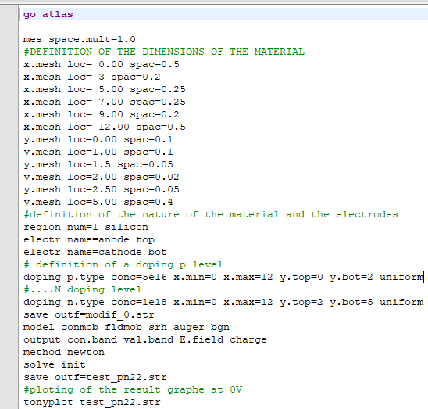
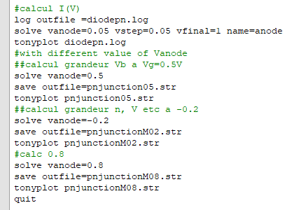

2)Simulation
The electrical characteristic
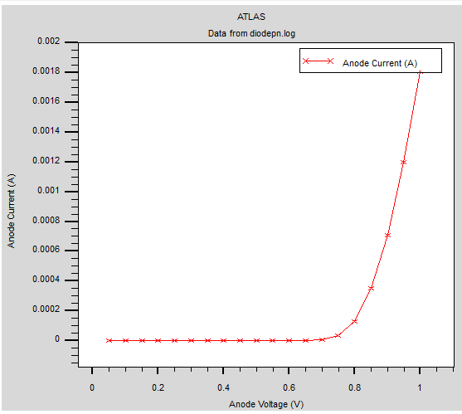

this curve show us the evolution of the current respect to the voltagge we can noctice the current doesn’t go up at 0V it need a certain value of Vanode to start going up (0.7V)
Electron need more energy to flow easily and create current
Experimentation :
Let’s make a cutline and trey get more properties of our material
a. The structure :
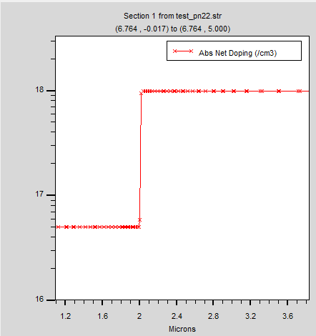
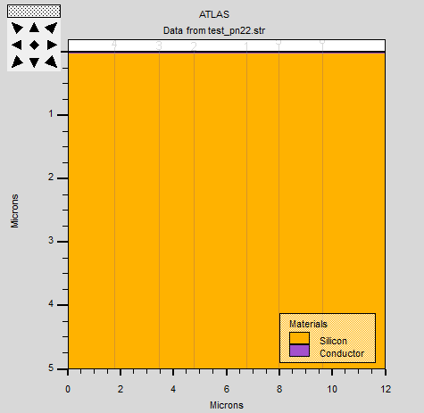
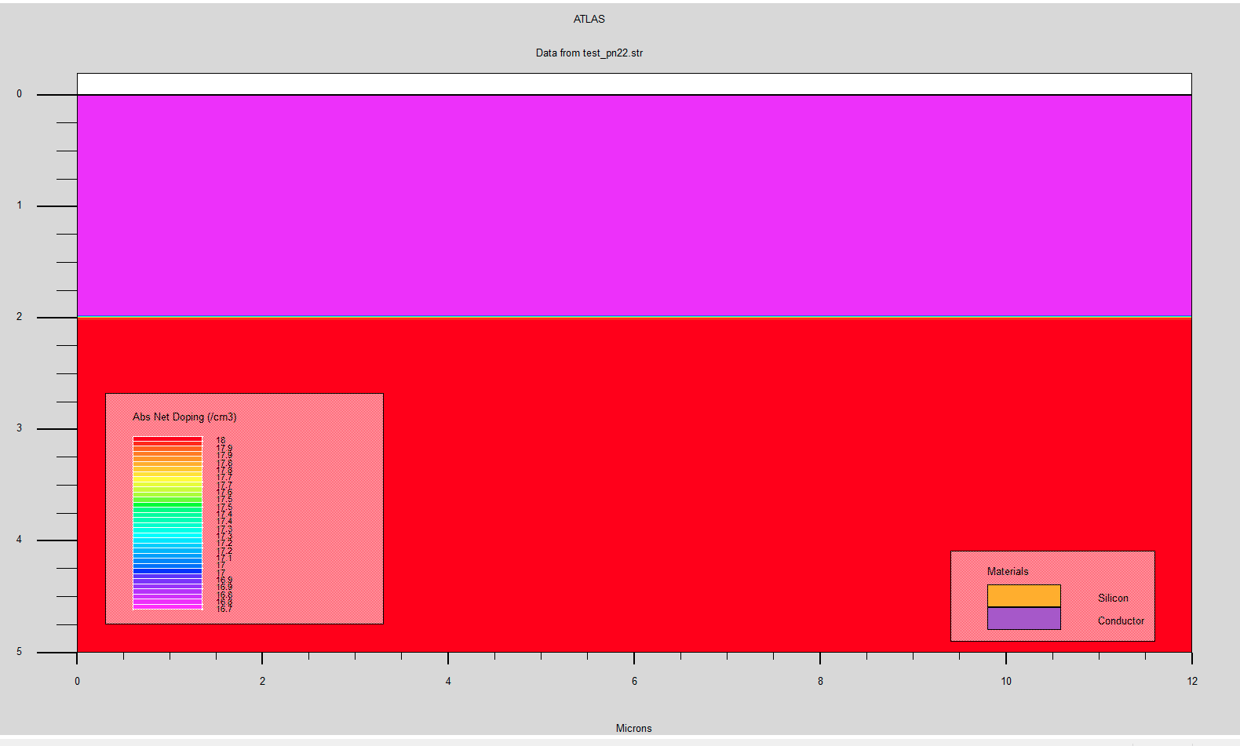

This picture represent the real structure of the material (12x5)µm
and also we doping level we cans see the difference between the two regions

b. Potential and Electric field

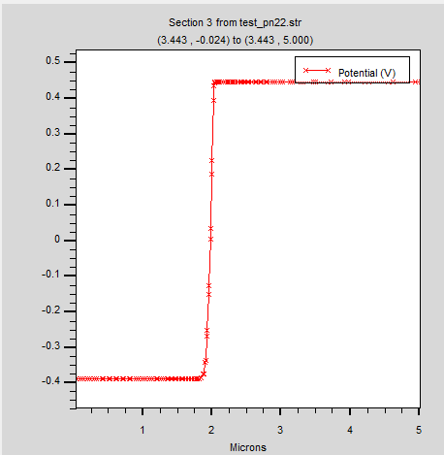
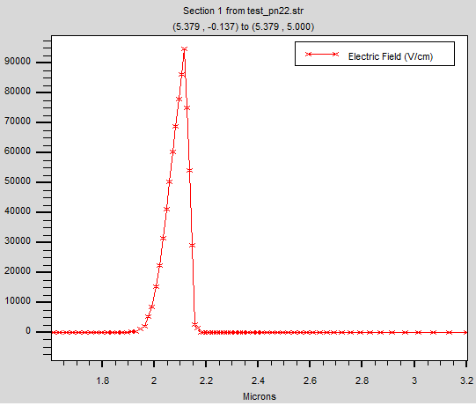

We can notice that is very high in the junction region 95000eV this is why meanwhile we have a negative potential around this region also we are at 0 voltage on the anode electon can’t go throught this barrier. This Electric field create a depletion region in which the numbre of electron is too much low.

c. Concentration and conduction band
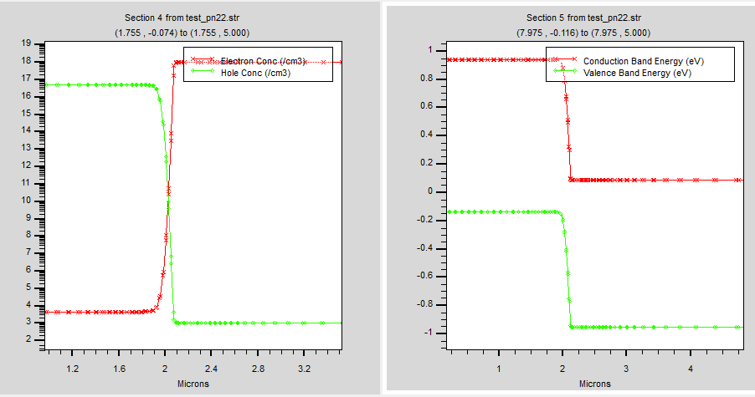

Fron the pictures below we can see that the electron concentration is fairly low on P doping region 0-2µm which is normal beacause we put 1e16 eV whereas in the N part we put 5e18 eV
On the right picture we see that the conduction band is decreasing because of the Electric field (barrier)
the gap between the two conduction band is high

3) simualtion with different value of Vanode
a. For Vanode= 0.5V
Potential and Electric field
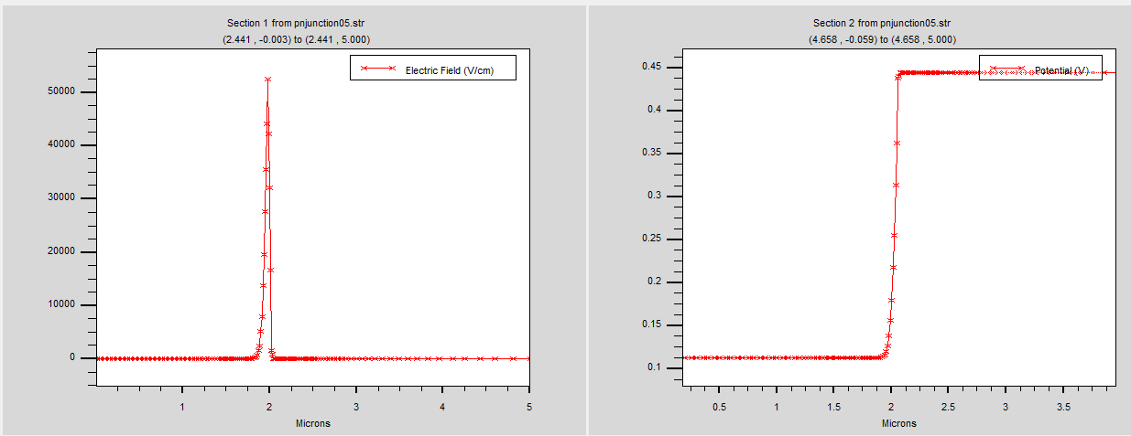

From these pictures above it is well shown that by applying a voltage the elctric field has decreased so that now we obtain 0.12 V on the junction zone

Concentration and conduction band

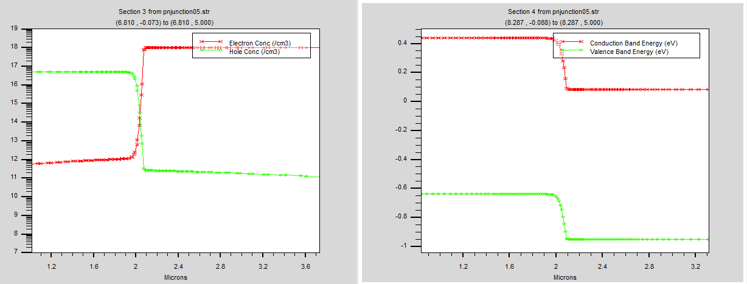
From these pictures above we see that by applyiong voltage we obtain more electron thant before the p zone, but there is no conduction between the two regions because of the electric field ; we reduced the gap between two regions condutions bands

b. For Vanode= 0.8V
Potential and Electric field

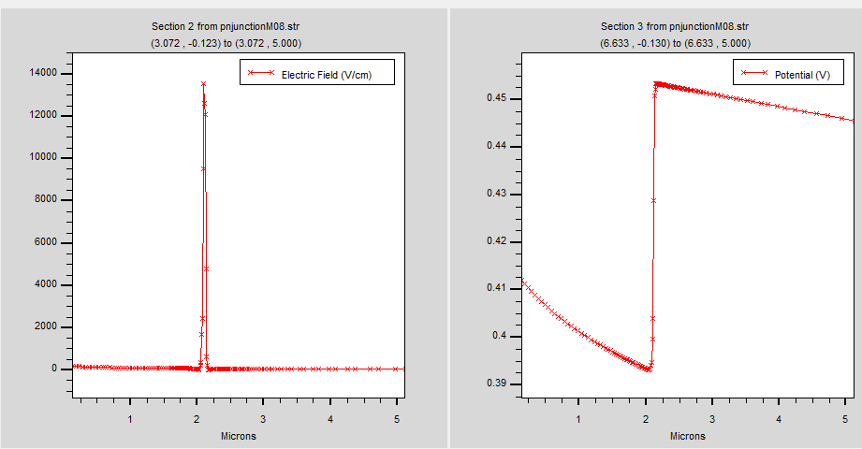

By applying 0.8 voltage we observe a low pic of electric field (14000) compare to its value at 0V
also the potential in the junction zone is higher the got much more energy

Concentration and conduction band

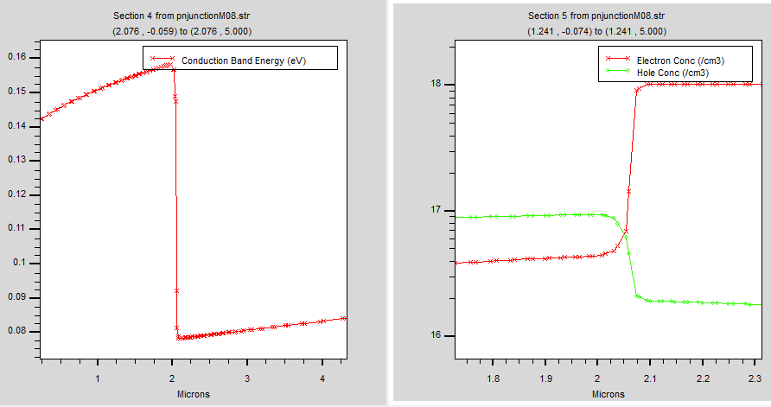

We can notice that we reduced much more the gap of the conduction band which is relate to the fermi level the exchange between the regions could be easy now
meanwhile the electron concentration keep increasing

c. For Vanode= -0.2V
Potential and Electric field

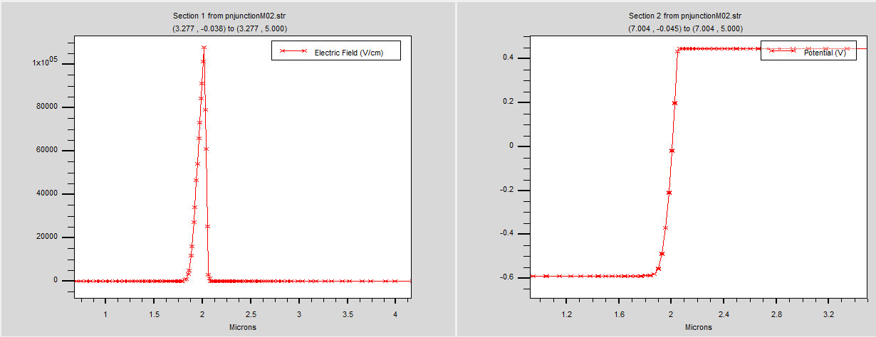
when we apply a negative voltage we increase the level of elctric field the barrier get high no electron can’t pass away also the potial reamin under 0 electron has no energy

Concentration and conduction band

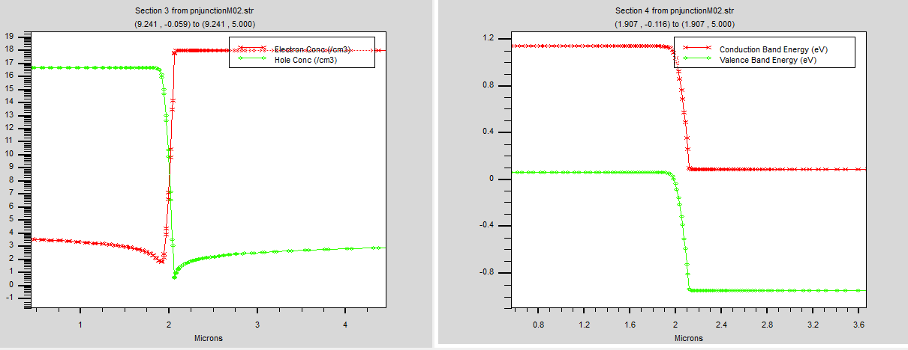
As said before there is almost no electron that mean the concentration of them are too low and also the gap between the conduction bands is so higher
the depletion has got higher

III. Conclusion
In conclusion, this lab experiment using SILVACO simulations has provided us with valuable insights into the behavior and characteristics of the PN junction. We have observed the diode's essential rectifying behavior, the formation of the depletion region, and its response to various biasing conditions.

